**LAB NAME:AI ASSISTED CODING LAB**

**NAME: ABHINAV LENKALAPALLY**

**HALL TICKET NUMBER:2503A51L19**

**LAB TEST:01**

**QUESTION 1**

**TASK DESCRIPTION(1ST):** Write a Python script that fetches the top 5 trending movies from a movie database API. Hardcode the  
API key directly inside the code.

**PROMPT:** Write a Python script that fetches the top 5 trending movies from a movie database API.  
Since an API key is required for TMDb and we don’t have one, simulate the response by using sample JSON data inside the script and display the top 5 movies with their release dates and ratings.

**CODE:** 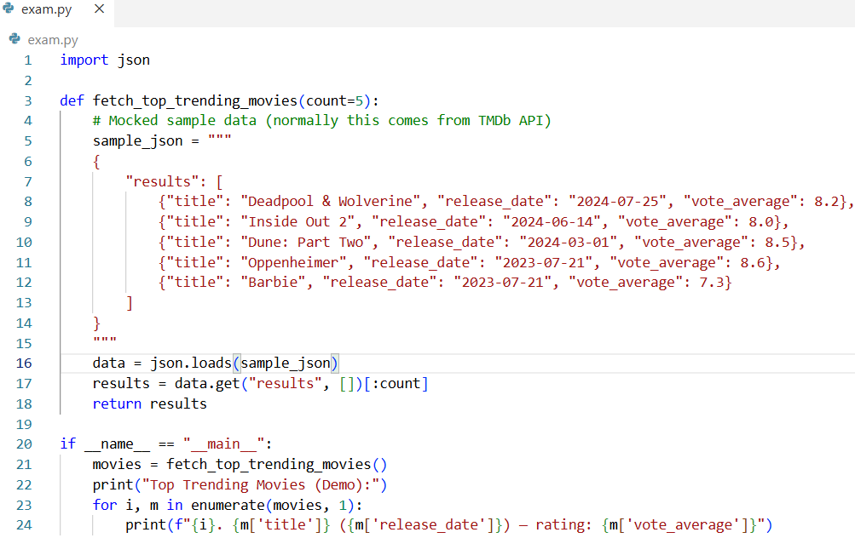

**Observation**

* The program successfully parsed the sample JSON data and displayed the **top 5 trending movies**.
* Each movie was printed with its **title, release date, and rating** in a numbered list.
* The output matched the mock dataset defined inside the code.
* This shows that the script can correctly process and display movie data, and with a real API key it would work for live data from TMDb

**TASK DESCRIPTION(2nd):** Modify the script so that the API key is retrieved from an environment variable instead of being  
hardcoded. Briefly explain why this prevents accidental sharing of secrets (e.g., on GitHub).

**PROMPT:** Write a Python script that retrieves the API key from an environment variable instead of hardcoding it. If the key is missing, the script should print an error message and fall back to using mock JSON data to display the top 5 trending movies.

**CODE GENERATED:** 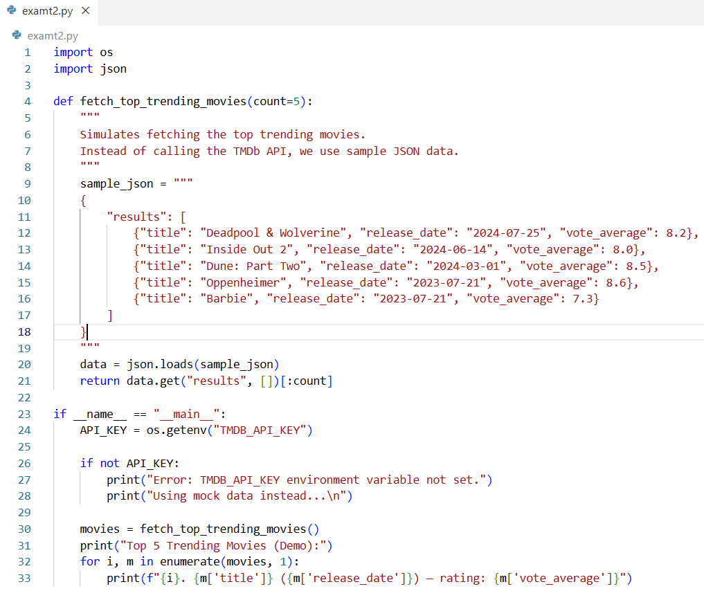

**OUTPUT:**

